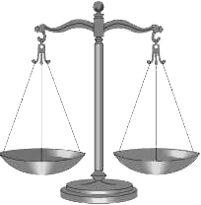
TRADE-OFFS IN THE BALANCE:
THE COST OF WAR TO ALAMANCE COUNTY TAXPAYERS

We will have paid $ 578.9 MILLION
for OUR SHARE OF THE IRAQ & AFGHANISTAN WARS
. . . ALL of the following
every year for eleven years:

- 139 Elementary school teachers &
- 973 Head Start slots for children &
- 2,663 Households converted to all
solar energy &
- 1,081 Military veterans receiving
VA medical care &
- 1,397 People receiving low-income healthcare &
- 149 Police or Sheriff’s Officers &
- 1,354 Students receiving Pell grants
of $5550

(as of Sept. 30, 2012)

BUT we COULD HAVE HAD THIS:

we will pay
$217.9 MILLION
for our share of the FY 2012 defense Budget.

IF that budget were
. . . ALL of the following
for one year:

- 58 Elementary school teachers &
- 403 Head Start slots for children &
- 1,102 Households converted to all
solar energy &
- 448 Military veterans receiving
VA medical care &
- 578 People receiving low-income healthcare &
- 62 Police or Sheriff’s Officers &
- 561 Students receiving Pell grants
of $5550

reduced by just 10%,
we could have this:

Source: National Priorities Project: http://costofwar.com/en/tradeoffs/state/NC/county/alamance-county/program/14/tradeoff/0/

