Alamance county
Taxpayers will pay
$217.9 MILLION
for our share
of the FY 2012
defense Budget.

IF that budget were
reduced by just 10%,
we could have this:
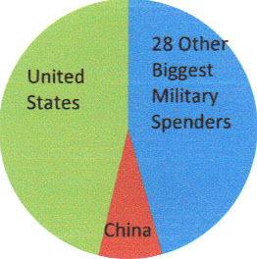

. . . ALL of the following
for one year:

- 58 Elementary school teachers and
- 403 Head Start slots for children and
- 1,102 Households converted to all
solar energy and
- 448 Military veterans receiving
VA medical care and
- 578 People receiving low-income healthcare and
- 62 Police or Sheriff’s Officers and
- 561 Students receiving Pell grants
of $5550

BRING THE WAR DOLLAR$ HOME
World Military Spending—
Do We Need More to be Safe?
Source: http://costofwar.com/en/tradeoffs/
World Military Spending
FUND OUR COMMUNITIES

An Alamance County
Community Forum

April 21, 2012
10:30 a.m. – noon
Church of the Holy Comforter, Burlington, NC
agenda

Welcome/Introductions…………………Anne Cassebaum

Bringing the War Dollars Home.............Pastor Robert Walker

Funding Our Community:
Hunger…………………………..Brenda Allen
Jobs.............................................Frances Walker
Public Transportation…………..Patrick Harman
Homelessness……………………Leo Welsh
Education……………………….Steve Van Pelt
Veterans’ Benefits………………William Franklin
Environment…………………….Mike Holland

Open Forum

Responses from Elected Officials and Candidates for Office

Next Steps: The Resolution Campaign
Proposed Resolution Calling upon the US Government
to Bring Our War Dollars Home and Fund Our Communities

Alamance County, North Carolina

BECAUSE the ongoing economic crisis impacts budgets at every level of government and requires us to re-examine our national spending priorities;

BECAUSE United States military spending, at nearly $700 billion per year, is greater than that of the next 17 countries combined;

BECAUSE over 6,300 US troops have been killed in Iraq and Afghanistan, more than 47,000 have been wounded, thousands have succumbed to trauma and suicide, and hundreds of thousands of civilian casualties have occurred in Iraq, Afghanistan, and Pakistan;

BECAUSE the cost to Alamance County of the wars in Iraq and Afghanistan since 2001 has been over $547 million; and because military spending represents an average of about $5,800 per year from each US household;

BECAUSE taxpayers in Alamance County will pay $217.9 million to fund the Department of Defense budget for fiscal year 2012; and
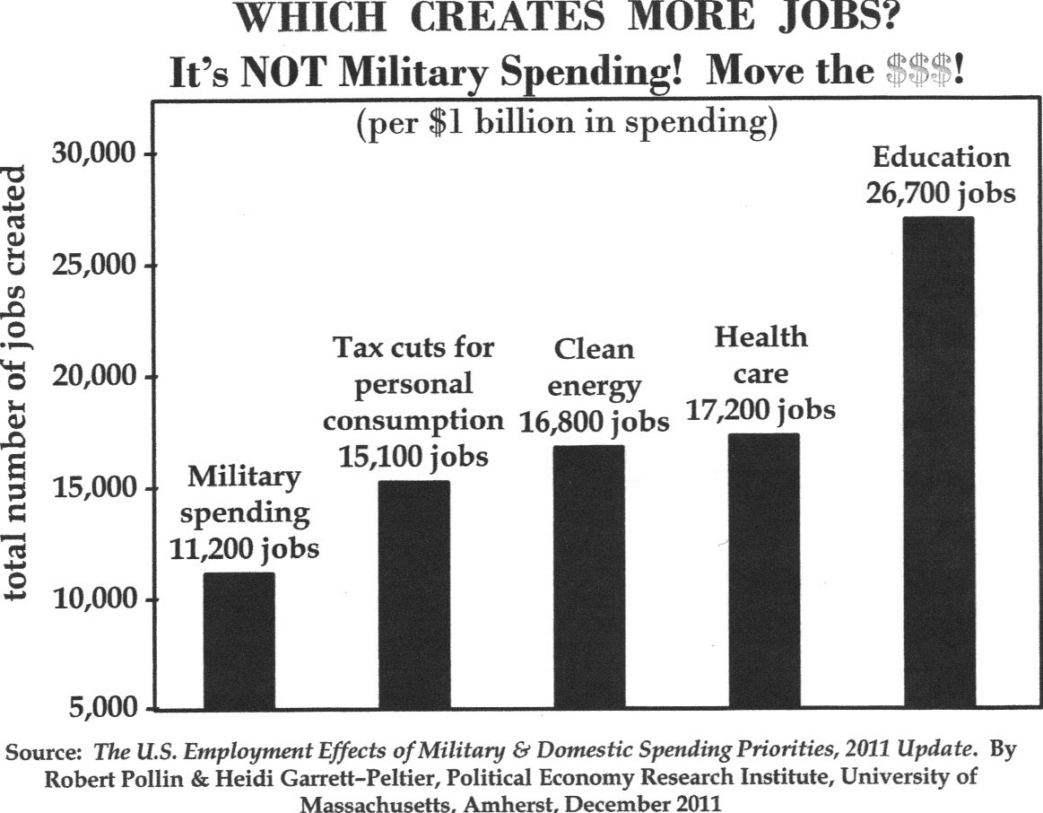
BECAUSE, dollar for dollar, domestic spending creates far more jobs than military spending;

NOW THEREFORE BE IT RESOLVED that __________________________
call upon the US Congress and President Obama to substantially reduce overall military spending and redirect our tax dollars to the pressing educational, employment, health, housing, nutritional, infrastructure, energy, and environmental needs of our communities.

Sources:

Cost of War http://costofwar.com/en/state/NC/county/alamance-county/
Department of Defense Casualty Statistics http://www.defense.gov/news/casualty.pdf
“Military Spending: Defense Costs: The Biggest Military Spenders” The Economist Online, June 8, 2011 http://www.economist.com/blogs/dailychart/2011/06/military-spending
National Priorities Project http://nationalpriorities.org/tools/tradeoffs/
Pollin, Robert & Heidi Garrett-Peltier. The U.S. Employment Effects of Military and Domestic Spending Priorities: An Updated Analysis. October 2009: Political Economy Research Institute, University of Massachusetts, Amherst http://www.peri.umass.edu/fileadmin/pdf/published_study/spending_priorities_PERI.pdf

